Chapter 9, Solution 78.

8+j6
R
Z

-jX

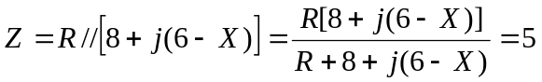

i.e 8R + j6R – jXR = 5R + 40 + j30 –j5X

Equating real and imaginary parts:

8R = 5R + 40 which leads to R=13.333Ω
6R-XR =30-5X which leads to X= 6 Ω.

